**SQL Assignment-3**

1. **write a SQL query to find Employees who have the biggest salary in their Department**

**Query:**

select emp_id,emp_name,emp.dept_id ,salary as biggest_salary,dept_name from emp

inner join dept on emp.dept_id = dept.dept_id where salary in (select max(salary) from emp group by dept_id);

**Output:**

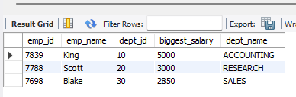

1. **write a SQL query to find Departments that have less than 3 people in it**

**Query:**

select dept.dept_name , emp.dept_id from emp inner join dept on emp.dept_id = dept.dept_id

group by dept_id

having count(emp_id)<3;

**Output:**

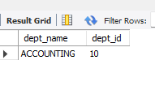

1. **write a SQL query to find All Department along with the number of people there**

**Query:**

select dept.dept_name ,dept.dept_id , count(emp_id) from dept inner join emp on emp.dept_id = dept.dept_id

group by dept_id ;

**Output:**

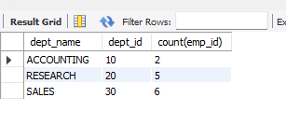

1. **write a SQL query to find All Department along with the total salary there**

**Query:**

select dept.dept_name,dept.dept_id,sum(salary) AS TOTAL_SALARY from dept inner join emp

on emp.dept_id = dept.dept_id

group by dept.dept_id;

**Output:**

